**Python Lab MST Worksheet – 1**

**Student Name:** Vivek Kumar  **UID:** 21BCS8129

**Branch:** BE-CSE (LEET) **Section/Group:** 809/A

**Semester:** 4th **Date of Performance:** 16/03/2022

**Subject Name:** Programming in Python Lab  **Subject Code:** 20CSP-259

**1. Aim/Overview of the practical:**

1. WAP to check whether the entered number is Armstrong or not.
2. WAP to find out the sum of the numbers between 1 to 100 which are not divisible by 2,4 and 7.

**2. Task to be done/ Which logistics used:**

1. Check and print the Armstrong number.
2. Check and print the sum of the numbers between 1 to 100 which is not divisible by 2,4 and 7.

**3. Steps for experiment/practical/Code:**

1. Check and print the Armstrong number.

**Sourse Code:**

num = int(input("Please Enter the Number: "))

order = len(str(num))

sum = 0

temp = num

while temp > 0:

digit = temp % 10

sum += digit ** order

temp //= 10

if num == sum:

print(num,"is an Armstrong number")

else:

print(num,"is not an Armstrong number")

1. Check and print the sum of the numbers between 1 to 100 which is not divisible by 2,4 and 7.

**Sourse Code:**

n = 1

max_num = 100

sum = 0

print("Sum of the Numbers not divisible by 2, 4 and 7 is ",end='')

while n <= max_num:

if n % 2 != 0 and n % 4 != 0 and n % 7 != 0:

sum+=n

n = n+1

print(sum)

**4. Result/Output/Writing Summary:**

1. Check and print the Armstrong number.

**Output:**

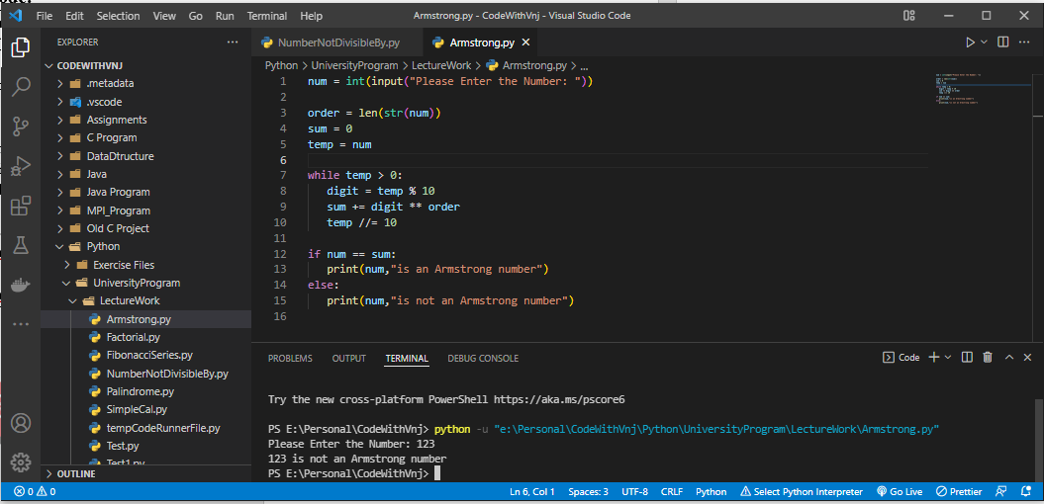

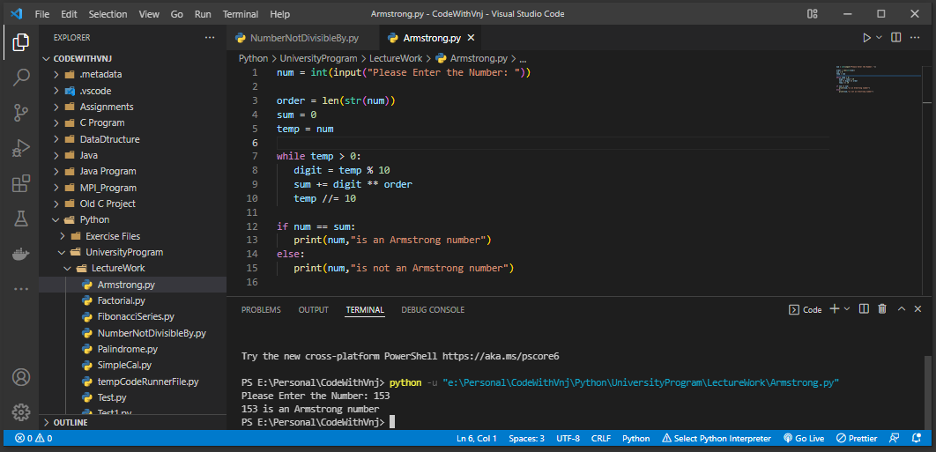

1. **C**heck and print the sum of the numbers between 1 to 100 which is not divisible by 2,4 and 7.

**Output:**

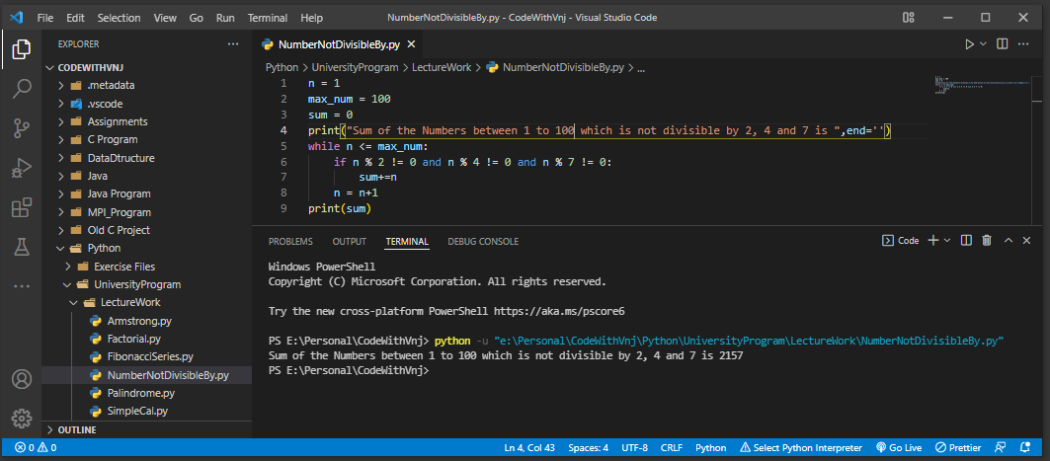

**Learning outcomes (What I have learnt):**

**1.** I have learnt, how to find Armstrong Number.

**2.** Learnt to use of and All Operators, including loops and conditions.

**Evaluation Grid (To be created as per the SOP and Assessment guidelines by the faculty):**

|  |  |  |  |
| --- | --- | --- | --- |
| Sr. No. | Parameters | Marks Obtained | Maximum Marks |
| 1. |  |  |  |
| 2. |  |  |  |
| 3. |  |  |  |
|  |  |  |  |